GT 00140 Jet Stream Project Task:
Execution of Requirement 325.1.2.1 “Modify filecertstore to be client/server”

Owner: | Jo Stichbury
Last revised: | 16th August 2002
Revision: | 0.04
Status: | DRAFT
Contributors:
Key Reviewers: | Leon Clarke, William Bamberg
Distribution
Approved By: |  | Approval Ref.:

Contents
1. Introduction 3
1.1 Purpose and scope 3
1.2 References 3
1.3 Open Issues 3
1.4 Glossary 3
1.5 Document History 3
2. Overview 4
3. Details 4
3.1 Client Side access to filecertstore 4
3.1.1 Proposed client side class relationships 6
3.2 Server Side access to filecertstore 6
3.2.1 Proposed server side class relationships 8
3.3 Jet Stream Detailed Level Requirements and the associated Project Task 9
3.3.1 Task 1 – Convert filecertstore to client/server framework 9
3.3.2 Task 2 – Implement readable filecertstore 9
3.3.3 Task 3 – Implement writable filecertstore 10
3.3.4 Timescale estimation 10

Introduction
This document outlines the project tasks for proposed changes to Security code to fulfil requirement REQ325.1.2.1 for Jet Stream. This includes details of the changes to filecertstore to make it client/server.
There is also some reference to the changes required to the cryptotokens framework, which is necessary for this work to be complete and fully tested. This constitutes part of the Jet Stream Detailed Level Requirement REQ328.3.1.1: “Split Cryptotokens to allow clients to not use dynamic linking”.
The document assumes familiarity with the current implementation of filecertstore, and intentionally does not describe implementation detail except briefly.

Purpose and scope
Describes the proposed class design plans for executing the project tasks which fulfil REQ325.1.2.1 for Jet Stream “Modify filecertstore to be client/server”: in terms of:
- component binaries and their interaction
- class hierarchies
- timescale for implementation, testing and code review

References
Jet Stream Detailed Level Requirements document: “Securing Security”
Security Subsystem v7.0 Architectural Analysis: SGL.GT0128.49

Open Issues

Glossary
The following technical terms and abbreviations are used within this document.
TCB – Trusted Computer Base

Document History
Date | Version | Status | Description
16-04-2002 | 0.01 | Draft | Initial Revision (+ modification following comments from Leon)
24/04/2002 | 0.02 | Draft | Modified timescale estimates and changed task description and their relation to the DLRs covered.
19/06/2002 | 0.03 | Draft | Extension to include server-side reference counting scheme and various other implementation details.
16/08/2002 | 0.04 | Draft | Updated and modified (class names, Rose diagrams etc) to reflect actual filetokens client/server implementation.

Overview
The filecertstore component must be converted to use the SymbianOS client/server paradigm as part of the “Securing Security Code” requirements for Jet Stream. At the same time, the API will also be made UI neutral to allow user interaction through a dialog.
The current implementation of filecertstore is a plugin dll, loaded by ECOM. This method of loading is deemed unsound for the TCB, which introduces the requirement that the component must also be accessible directly. However, rather than remove ECOM dependence totally from the cryptotoken framework, an additional mechanism will be provided as an alternative way to access filecertstore functionality. [This necessitates some minor changes to the code within the cryptotoken framework which will form part of a separate project task to execute the Jet Stream detailed level requirement REQ328.3.1.1: “Split Cryptotokens to allow clients to not use dynamic linking” described thus: “…It should be possible for clients (Software Install Server) who know which token(s) they want to load them directly without going via ECom or linking to ECom…”].
The suggested client/server design has intentionally been made as generic as possible to provide a base framework for future implementations of client/server cryptotokens. Future potential requirements to support multiple tokens of a particular token type have been considered, and should not entail major changes. The client is intentionally generic, and should be extendable and reused for other tokentype servers as they are introduced. The server also provides a base reusable framework, which can be implemented for different tokentype servers as required.

Details

Client Side access to filecertstore
Client side, the filecertstore component is to be split into two dlls. Firstly, an ECOM plug-in dll will be retained (tokentypeplugin.dll), though will be nothing more than the implementation of a single entry point, ImplementationGroupProxy, to allow it to be loaded dynamically by ECOM as previously. It will be statically linked to the second, new dll (tokentypeclient.dll), the main filecertstore client implementation. The code in this dll will initially reflect client access to a certificate store, though may later be extended for other token interfaces (e.g. key storage). The code is generic and is intended to be reused for access to other tokentype servers (e.g. removable certificate store).
The top level class is a client side implementation of a CTTokenType-derived class. The NewL() function takes arguments to identify the tokentype server to connect to (e.g. file-based store or removeable), the token and interface identifiers to be opened on the token (e.g. writable certificate store). Depending on the tokentype required by the caller, the function opens a connection to the tokentype server, by instantiating the appropriate client RSessionBase-derived class.
This function may also be accessed directly, with no requirement to dynamically load the ECOM plugin dll, as required by the TCB. Thus, the SWInstall component will call a separate NewTokenTypeL() function exported by tokentypeclient.dll which passes the appropriate parameters to NewL() to instantiate and return the CTTokenType-subclass object.
The CTTokenType derived class implements the MCTTokenType interface functions inasmuch as it provides a wrapper around calls to the TokenType server and instantiates the appropriate client-side objects to reflect those calls, where necessary.
Thus the List() function will call through to the connected server to list the available tokens for its appropriate type (for the filestore tokentype, this will initially be a token representing the on-device certificate store). Server side classes will be described separately (see below), but ultimately, for the purposes of this description, a server side object deriving from CCTTokenType will receive and service the ‘List’ request.
The OpenToken function will call through to the server, which will create the appropriate token (in the first instance this will be the on-device certificate store) and pass back an identifying token handle. Client side, an object of type CCTTokenClient (a generic client side wrapper class which implements the MCTToken interface) will be created – this is the object returned to the caller of OpenToken. The client side object stores the returned handle to the server side token object, and passes calls on the MCTToken interface through to the server object using the identifying handle.
The GetInterface method on the MCTToken client object will call the corresponding object on the server to retrieve the required MCTTokenInterface. If the token supports this interface, this will create a server-side object (described later) implementing this interface and pass back an appropriate identifier to the client, which stores it as part of a MCTTokenInterface derived wrapper object. This part of the client implementation is necessarily specific to the type of interfaces to be accessed on the token. In the first instance, these will be MCTWritableCertStore and MCTCertStore. The client side wrapper class deriving from these interfaces will be CFSCertStoreClient.
RSubSessionBase derived classes are not used for these interfaces because, there will be a limited number of interfaces possible.

Proposed client side class relationships
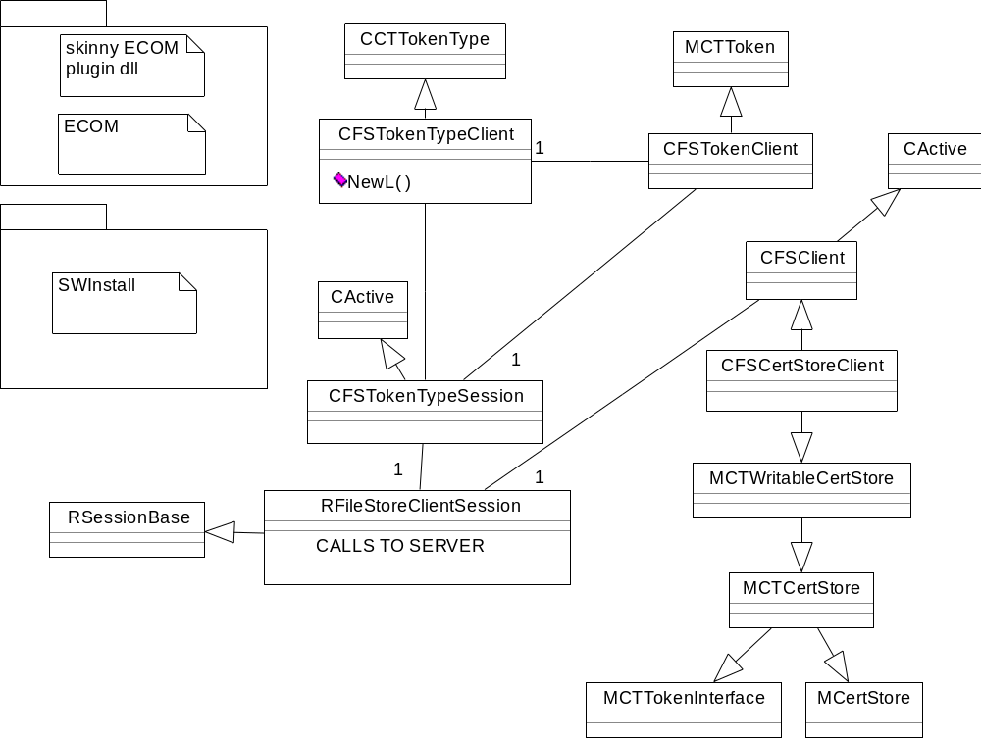

Server Side access to filecertstore
The server runs as a separate process which is started by the client upon first connection, and will be transient (i.e. will close and unload itself when the last outstanding session upon it is closed). The server will also guard against being started more than once, and uses a well-defined IPC mechanism to ‘synchronise’ start-up with the client.
The server object represents a file store tokentype, and initially will implement only the on-device certificate store – although an implementation of the interface for an on-device key store may also be added to the token.
The server will define the two standard Symbian OS classes, derived from CSharableSession and CServer, to implement the server and interact with the client. The session class will provide a ServiceL() method which inspects the message enumerator received from the client and dispatches it accordingly. On receipt of a ENewTokenType message, the session object inspects the type of tokentype required and creates an object of the appropriate type (CFSTokenTypeServer for this instance of the server – the code can be reused at a later stage for different tokentypes). CTokenServerSession::ServiceL will pass most client requests, with corresponding RMessage payload, directly to the CFileStoreTokenType object.
In effect, the current filecertstore code has been ‘pushed down’ into the server, to be accessed by a series of client calls identified by an enumeration value and RMessage payload. To maintain a reference counting scheme server side, the use of CObject derived classes has been required. These objects effectively wrap the tokentype, token and token interface objects and are container-ised and indexed for proper reference counting. Whenever a token or token interface object is created and index, the index value is returned to the client to represent the client handle to that object. The client must then use the handle to address the appropriate server side object.
CFSTokenTypeServer derives from CCTTokenType and implements the MCTTokenType functions (List and OpenToken). On receipt of a request to OpenToken, for the appropriate token and type, the server will access an object of type CFSCertStoreToken which, in this implementation, represents the on-device certificate store. The class derives from MCTToken and implements the functions of that interface. For example, a client request to open an MCTTokenInterface (MCTCertStore or MCTWritableCertStore) will create the CFSCertStoreServer object with appropriate file access flag. This object services requests upon the filecertstore, through MCTCertStore or MCTWritable interfaces. The CFSCertStoreServer class, and those it accesses, are more or less unchanged from the current implementation of the filecertstore except that they have been made singleton instance to ensure reference counting is correctly enforced on the server (which may have multiple clients).

Proposed server side class relationships
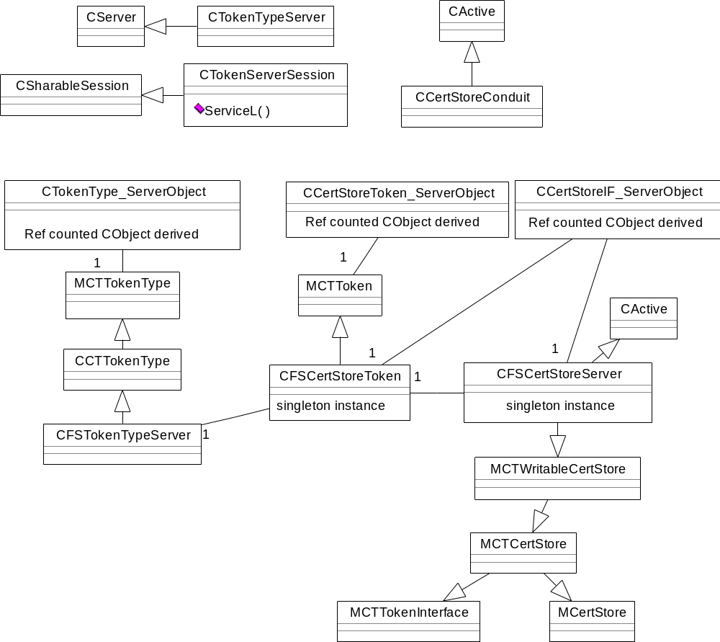

Jet Stream Detailed Level Requirements and the associated Project Task

Task 1 – Convert filecertstore to client/server framework
Requirement | Task 1 Details | Estimated time to complete
REQ325.1.2.1.1: Server start/stop  The client will be able to open a token, which will start up the server. Closing the token should stop the server. | - Create skinny ECOM plugin dll, filecertstore client dll and server components  - Implement transient client/server skeleton code | 3 days
REQ325.1.2.1.2: Opening cert stores  The client will be able to open and close cert store interfaces on the token, which will create appropriate server-side objects | - Add classes to reflect client side implementation of MCTTokenType, MCTToken, MCTCertStore and MCTWritableCertStore  - Add appropriate server side code to “wrap” the current filecertstore implementation | 1 day
Supply additional unit test code to current filecertstore test harness |  | 1 day

Task 2 – Implement readable filecertstore
Requirement | Task 2 Details | Estimated time to complete
REQ325.1.2.1.3: Get a CCTCertInfo  The client will be able to retrieve individual CCTCertInfos by handle | Implementation of MCTCertStore::GetCert() | 1 day
REQ325.1.2.1.4: List CCTCertInfos  The client will be able to list CCTCertInfo objects that match certain criterea | Implementation of MCTCertStore::List() | 1 day
REQ325.1.2.1.5: Get Applications  The client will be able to get the applications of a given certificate | Implementation of MCTCertStore::Applications() | ⅓ day
REQ325.1.2.1.6: Check the applicability of a certificate for a particular application  The client will be able to Check the applicability of a certificate for a particular application | Implementation of MCTCertStore::IsApplicable() | ⅓ day
REQ325.1.2.1.7: Get trust settings  The client will be able to get the trust settings of a certificate | Implementation of MCTCertStore::Trusted() | ⅓ day
REQ325.1.2.1.8: Retrieve a certificate  The client will be able to retrieve the data of the certificate | Implementation of MCTCertStore::Retrieve() | 1 day
Supply additional unit test code to current filecertstore test harness |  | 1 day

Task 3 – Implement writable filecertstore
Requirement | Task 3 Details | Estimated time to complete
REQ325.1.2.1.9: Open and close a writeble cert store  The client will be able to open and close writeable cert store interfaces on the token, which will create appropriate server-side objects. All clients can access the APIs on the writeable cert store interface, but these APIs will all display secure dialogs to confirm with the user that the operation is acceptable. | - Client Side: CCTCertStoreClient  - Server Side: CFileCertStore | ½ day
REQ325.1.2.1.10: Add a certificate  The client will be able to add a certificate via the writeable cert store interface. | MCTWritableCertStore::Add() | ½ day
REQ325.1.2.1.11: Delete a certificate  The client will be able to delete a certificate via the writeable cert store interface. | MCTWritableCertStore::Remove() | ½ day
REQ325.1.2.1.12: Edit a certificate  The client will be able to allow the user to edit the applicability and trust of a certificate via the writeable cert store interface. | UI neutral MCTWritableCertStore::EditTrust() and MCTWritableCertStore::EditApplicability() | ½ day
Supply additional unit test code to current filecertstore test harness |  | 1 day

Timescale estimation
Code development (including supplying additional test code) = 12 days
Additional documentation (integral with code, written documents, class diagrams) = 1½ days
Code review (preparation and review) ½ day
Total time estimated = 15 days

